IIH – Strategic goods ONHOLD control
9 Apr 2010
Inbound
New Skugroup = STHOLD
To apply same logic as Strategic goods.
Require to putaway to the defined location in SKU Master ( SKU.PutawayLoc)

Outbound
for those SKU that is required to put "On Hold" , we just setup the SKUGroup = STHOLD,
then the Order shipment will block this goods from allocation.

Changes:
1. SKU Setup – add skugroup codelkup = STHOLD
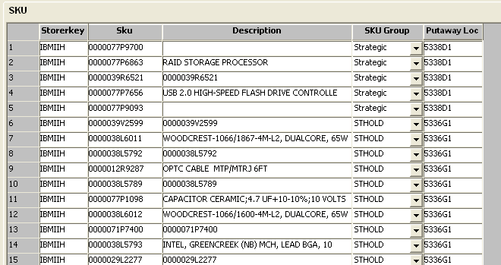
2. ITS:
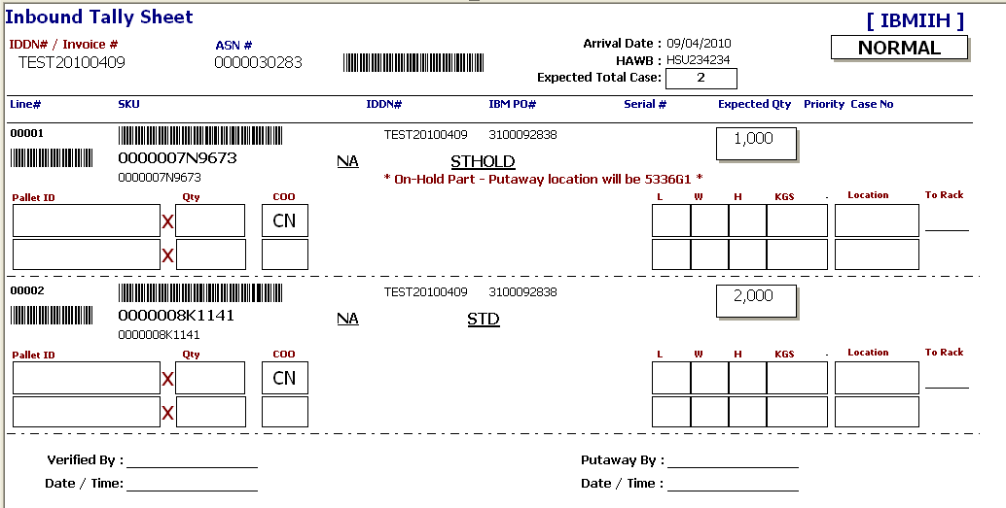
3. RF Receiving
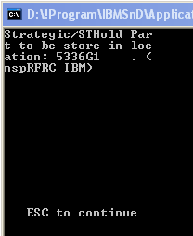
4. RF Move
- to block STHOLD stock out from defined location
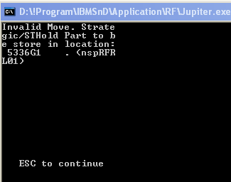
5. Outbound – Allocation
